In this Homework, you have to solve a Quadratic Equation.

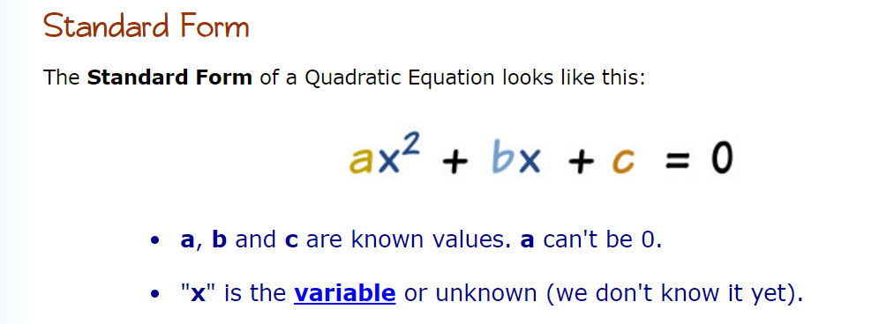

The variables **a**, **b** and **c** also called coefficients. You have to check all values because for Standard Form all coefficients must not be equals zero.

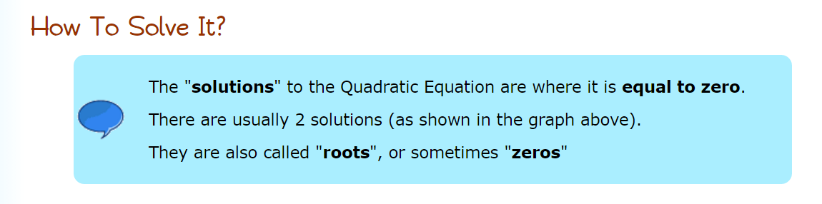

**One of the ways to find a solution is:**

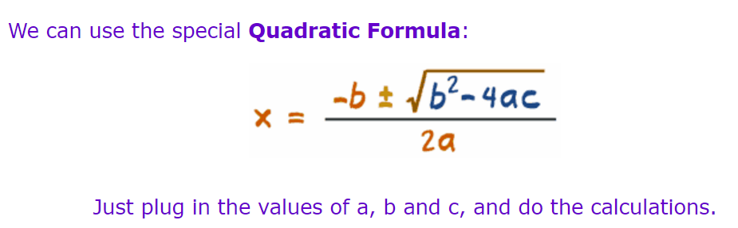

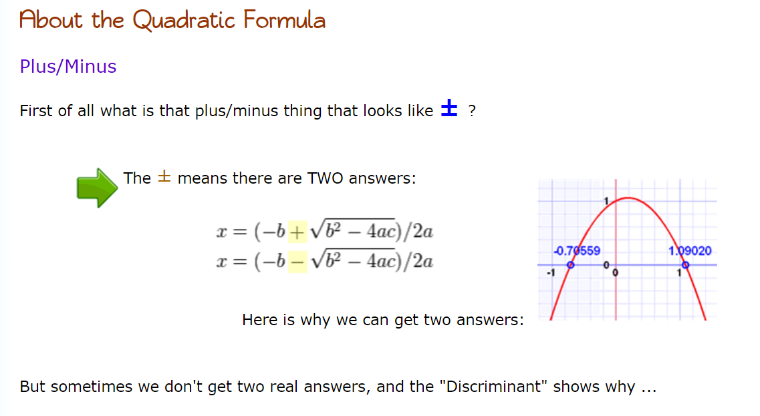

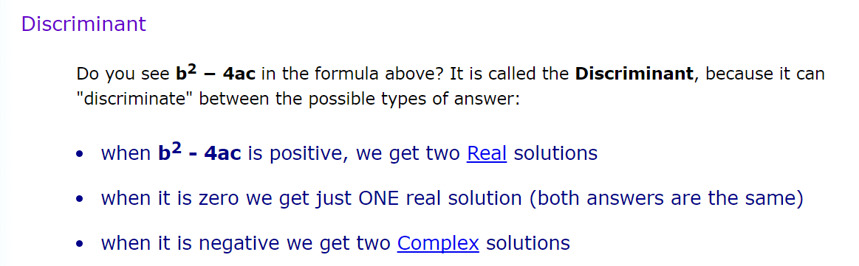

In this homework, you don’t need to use Complex solutions. If the Discriminant is negative, just provide a message that this quadratic equation doesn’t have any real roots.

**Instructions:**

1. Ask the user to enter successively three coefficients for the quadratic equation, with names a, b, and c.
2. Check this input. All coefficients must not be equals zero. If even one of the coefficients equals zero, the program should output the error message as follows - **This is not a Standard Form of Quadratic Equation**!
3. Calculate the Discriminant, according to the formula.
4. Analyze the value of the Discriminant.
   1. If the Discriminant is positive, your program should calculate two roots, according to formulas, and output the appropriate message. Use the function **sqrt()** from **math** library in roots calculation.
   2. If the Discriminant is equaled zero, the program calculates only one root and outputs the appropriate message.
   3. If the Discriminant is negative, it means, there are no roots, the program should only output the message.
5. Don’t forget about comments and report.

**Examples for testing and output:**

1. **Input**: a=5, b=-6, c=1

**Output**:

**The Quadratic Equation 5x^2+6x+1=0 has two roots.**

**x1=-0.2 and x2=-1.0**

1. **Input**: a=1, b=4 c=4

**Output**:

**The Quadratic Equation x^2+4x+4=0 has one root because the Discriminant is equaled zero.**

**x=-2**

1. **Input**: a=5, b=2 c=1

**Output**:

**The Quadratic Equation x^2+4x+4=0 has no roots because the Discriminant is negative.**